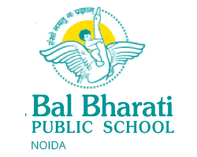

**CERTIFICATE**

This is to certify that Saumya Datt and Divyansh Mishra of class XII-B have completed their Artificial Intelligence project titled ‘Trekker’ under my supervision and guidance as per the guidelines issued by CBSE for the academic year 2023-2024.

____________________

Ms. Asha Menon

Bal Bharati Public School, Noida